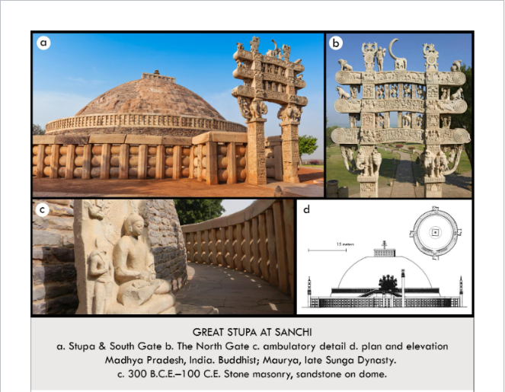

| **Form:**  Solid mound covered in stone work. Teran: carved piece of art architecture. Stone covered and rubbled dome. 50ft high. Sold mound. Sandstone tornanas. 4 Teran gateways  **Function:**  Part of a monastery site, for Buddhist worship. It's a reliquary ( bones of the Buddah)  **Content:**  Contains relics of the Buddha. Enter the site beneath stone carved tornanas, climb stairs on the south side/ contains 600 inscriptions indicating donors- men and women, laypeople and monks. Tornanas: carved gateway with goddesses carved along the sides. Yakshi, sensual and naked  **Context:**  Constructed as a monastery site in the regions of king Ashoka( united the indian clans). Took about 100 years to construct the whole structure. Built 400 years after the man died. Oldest Buddhist piece of architecture in the world. Oldest stone temple. Therana gateways mark the entrance of sacred sites.  **Compare:**  The Kabba in Mecca, Gateway: teminum reliefs: Church or st. foy tympanum  **192**  South, east & southeast asia |
| --- |

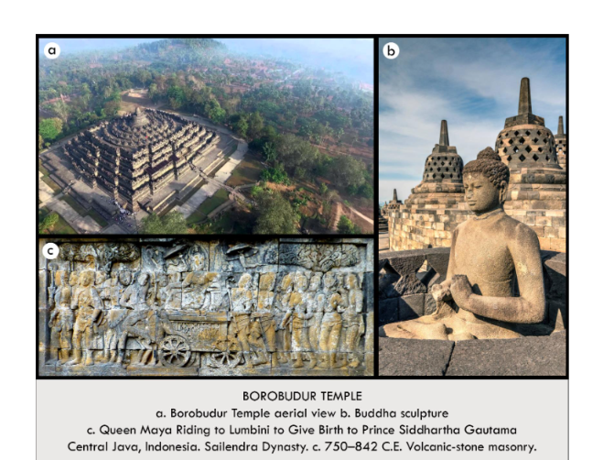

| **Form:**  Cosmic mountain over a small hill built on 9 terraces accessed by 4 stairways oriented to the compass monument it 400’ per side, 98’ tall and made of million blocks of volcanic sandstone  **Function:**  Place of pilgrimage, visitors circumambulate each terrace.  **Content:**  each terrace passing more than 500 life sized Buddhas at least 1000 reliefs and 1500 stubas.  **Context:**  Built in the 9th century during the reign of Sailendra Dynasty; the largest Buddhaest temple on planet earth. Debated and complex meaning visitors ascend through three levels. c) Shows prince sidartha becoming the buddha, queen maya riding horse carriage Retreating to Lumbini to give birth to Prince Siddarthta Gautana  **Compare:**  Kabba, chartres cathedral  **198**  South, east & southeast asia |
| --- |

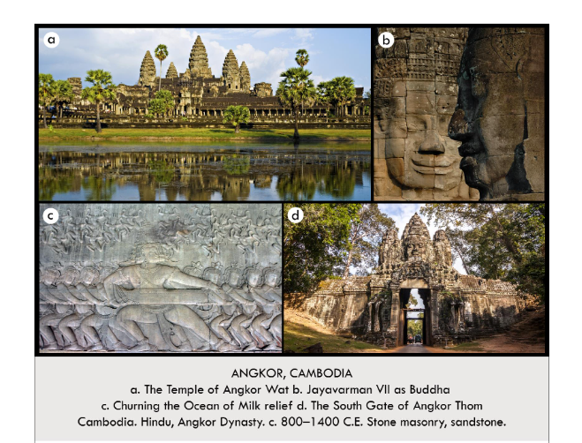

| **Form:**  (largest most famous) It measures 4000’ by 5000, stone towers with indian corbelled vaulting. Stone reliefs. The complex is hundreds of acres. c) 100 ft long  **Function:**  Dedicated to Vishnu mostly, and many other Gods. “Kings temples”  **Content:**  Complex of temples and places with a mixed Hindu and Buddist character. Largest Angor Was built by Suryavarman 2 and is dedicated to Vishmu- saryavarman, vaulting symbolises the five peaks of the\sacred Mount Meru and the center of the universe. b) medieval rulers associated themselves with the God of their choice. c) shows demons on left and Gods on the right, struggle of good and evil. Snake wrapped around the mountain of the universe( mt. Mandara) and from the sea they are milking the nectar of eternal life.  **Context:**  Built over 4 centuries by successive Khmer Kings , Each king temple depicted their personal gd and themselves as an earthy manifestation of that god  **Compare:**  **199**  South, east & southeast asia |
| --- |

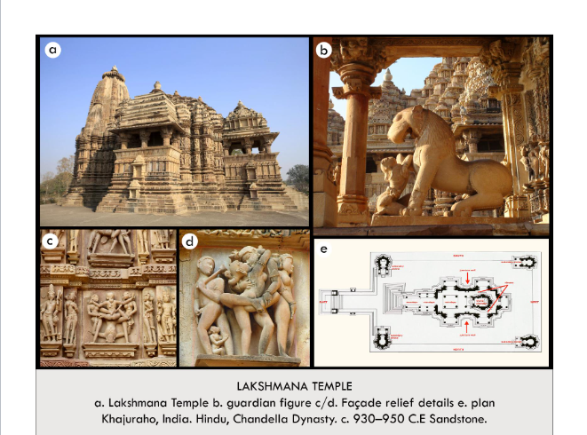

| **Form:**  Layers of sandstone, a compact temple placed on a high pedestal created with blocks of carved sandstone using ashakar masonry, beehive corbelled roof, east-west oriented.  **Function:**  Early residence of Lakshama devoted to the brother of Rama.  **Content:**  Sunrise lit interior. Inner ambulatory sandara and tiny cella *Womb of the World* chamber where the cult statue resides. Erotic carvings are harmoniously-integrated with architecture provide protection, symbolize regeneration  **Context:**  Prodate the gothic.  **Compare:**  Gothic Cathedrals  **200**  South, east & southeast asia |
| --- |

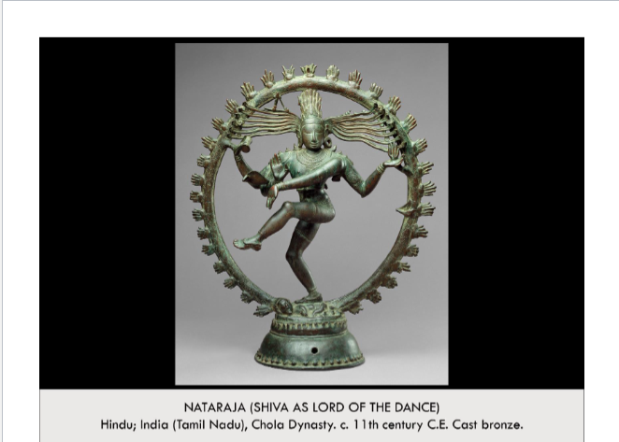

| **Form:**  A bronze statue that is 2’11.25” high  **Function:**  A statue dedicated to Shiva for Hindu worship/ meditation  **Content:**  Depicts shiva- god. Standing in a nimbus of fires, he is standing on a dwarf of ignorance. Hand position saying it's going to be ok. Flames- destruction, Three coiled snake- past present and future, Thorana arch or nimbus- birth and rebirth, Arms and hands: assurance, Damaru Drum: the rhythmic vibration of creation, The malevolent dwarf: symbolizes ignorance) Lotus petal: rebirth  **Context:**  Found in hindu temples or in private homes, Sivas roal is to dance the earth into destruction so it may be reborn.  **Compare:**  **202**  South, east & southeast asia |
| --- |

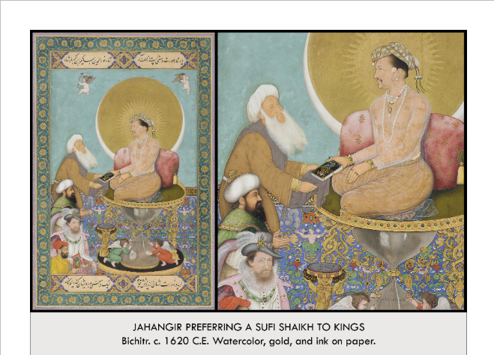

| **Form:**  Water color on paper, 1ft by 1.5 f. Jahangir seated on a hourglass form and 2 angles are down on the bottom of the hourglass, self portar of bicitra who is seated and next to him is a european kings and above his is a sultif and above his is and sands of time running out Jahangir scene in a god like way, a source of light. The halo of the sun and moon behind him  **Function:**  Piece of propaganda that makes Jahangir a holy man instead if just a ruler.  **Content:**  Shows skill and prediction, painting very small and, shows indian native styles and european styles. The theme is him preferring the holy word or the bible. Clothed cupits who are describing the trone that say that Jahangir lives for 1000 years. The design work to persian painting, Kufic calligraphy, indian way of painting the body  **Context:**  Created as a single page and not part of a book  India piece of miniature painting  Artist sign name on the top of food stool, having his name stepped upon showing  **Compare:**  **208**  South, east & southeast asia |
| --- |

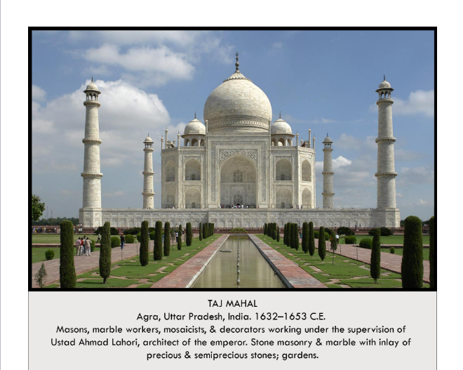

| **Form:**  Mathematically proportion, as wide as it is tall, height of the dome= height of the facade. White stone walls are patterned with pointed- arch niches creating a feeling of weightlessness.  **Function:** Mausoleum, a place for burial.  **Content:**  Designed by Ustad Ahmad Lahori, circle being united with the octagon. Symmetric. building features an onion, crowned shaped dome. It is flanked by 4 small domes. Over a square with octagonal corners in a platform with 4 carefully created minarets at each corner . tessellations.  **Context:**  Means the crown palace, it was built by Shah Jaham for his wife, Muzmtaz who are both buried inside. Next to river Yamuna in uper india , islam and inda are some of the powerhouses of math. Called the most beautiful public building in the world.  **Compare:**  Ewans od the isfahan mosque, gardens of vasi, Great pyramids of egypt (giza)  **209**  South, east & southeast asia |
| --- |

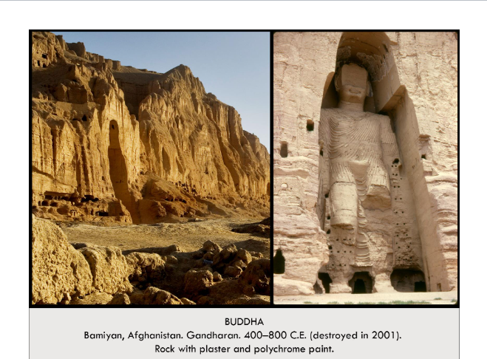

| **Form:**  175’ tall, cave complex ,- the larger Buddha. The vairocana Buddha, The smaller Buddah 115ft tall, represents sakyamuni  **Function:**  Pilgrimage sight along a trading path  **Content:**  A niche is shaped like a halo or mandorla around the body, statues originally covered in pigment and gold  **Context:**  Bamiyan was a trading and religious center at the end of the silk road in modern day Afghanistan. They were destroyed by the taliban ( allah is a jealous god)  **Compare:**  **182**  West and Central Asia |
| --- |

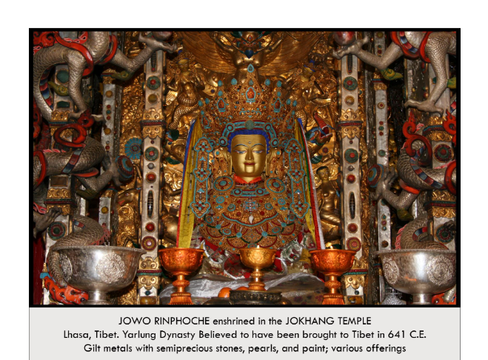

| **Form:**  Very opulent and made of gold and precious gems and stones. Inlaid buddha. Made of gilt metal  **Function:**  Statue of the buddha for meditative servaes in the Jokhang temple. Religious and cultural importance ( seen through its restoration)  **Content:**  Jova means lord. Consisted of many precious jewels and gold, which made it very valuable.  **Context:**  Tibetan buddhism, dalai lama is the leader of tibetan buddha. The oldest tubentain Buddha work, earliest sculpture of the Buddha and the earliest temple dedicated to buddha. Enshrined in the Jokhang Temple foremost founded 647 by the first unified Tibet ruler. Was destroyed by china and only recently  **Compare:** Reliquary of saint foy  **184**  West and Central Asia |
| --- |

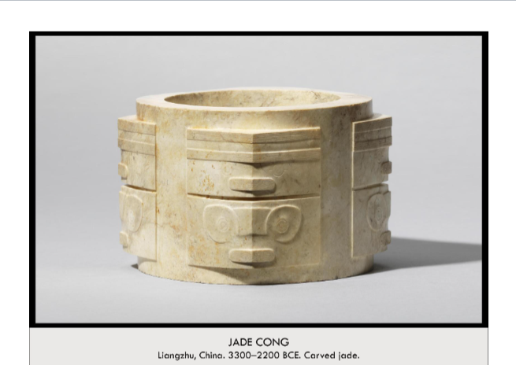

| **Form:**  Carved out of Jade, carved with knives and drills to create these.  **Function:**  Unknown. Possible used as a burial ritual, buried with a high ranking official may have been a ritual bowl for sacrifices. Funerary purposes  **Content:**  Found with skeletons, shape is a circle inside a square,might relate with earth and heaven. each corner is a small abstract face, mouth and two eyes, mask like images with eyes and fanged mouth. Abstract patterning,  **Context:**  Chinas appreciation of Nature and river stones. Comes from neolithic themes in china, prehistoric( pre writing) only find the Jade Congs in burials of high ranking peoples. Some were found brocken with  **Compare**: ...Dome of the rock ? (kind of)  **07**  Global Prehistory |
| --- |

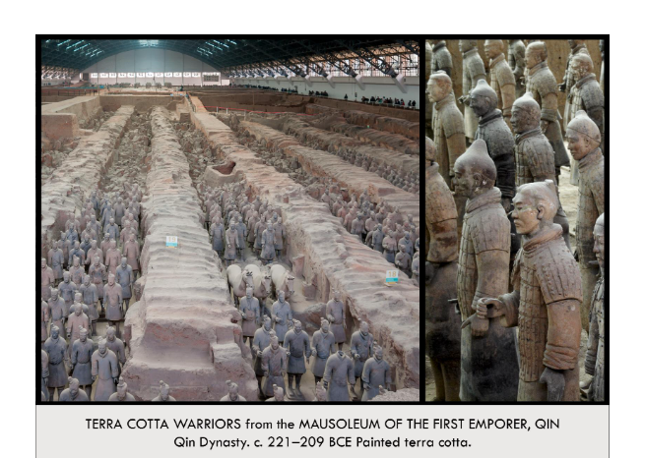

| **Form:**  Painted Terra Cotta. 8,000 or more objects of a terra cotta army, archers, solidars, other figures. Some made out of bronze. 100 woden chariots 2 bronze chariots 30000 weapons. Originally colorfully painted. 22 square miles  **Function:**As a tomb, guardian figures for the emperors tomb palace. ( created as the afterlife army to guard Emperor Shi Hunangdi)  **Content:**  Shows the army of the emperor Shi Huangdi ( the 1st emperor of Qin) They created different looking individuals with different molds and hand modeled some of the faces. Many were painted. Made from common mold, earth was made with realism/ realistic features. Slightly over life-sized. Very naturalistic. Guarding a place that was fulled with gold and riches.  **Context:**  Discovered when farmers were digging a well. 700,000 laborars/ceramicists had to make this/ wired on this. This was made as a part of this tomb. There is an entire underground palace thought to be filled with gold and riches. Buried for 2,00 years. 221-209 BCE, Qin Dynasty. Has yet to be excavated in china. Ongoing excavation site( tomb palace in not excavated). Discovered in 1974. Was the emperor who constructed some of the great wall of china. He created and single unified country=china was born. Standardized everything. Theory that they got the naturalism inspiration from the greek statues.  **Compare:** The great pyramids of gia  **193**  South, east & southeast asia |
| --- |

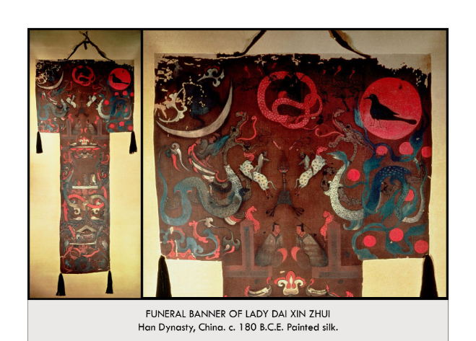

| **Form:**  Tasseled silk shroud. Painted silk. Pained Banner  **Function:**Funerary banner of Lady Dai Xin Zhui. A cosmology painting. Wishing Lady Dai a good afterlife.  **Content:** Cosmology of the afterlife, sun and the moon. Yin and yang/ The bottom half is an artistic representation on the underworld. Dragon tails reachinging into the underworld. The earthly realm is a funerary feast for the women in the tomb. Birds with human heads on a tassel. Feast displays the coffin. Earthly realm in the middle representing above the underworld. Dragons represent yin and yang. Top is the earthly realms on the way to heaven. SHe is beginning her journey to heaven. Phoenixes resting on the canopy. Dragons leading her up to heaven.  Underworld- feast- heaven with the dragons representing yin and yang- heaven  Reaches heaven and shows yin energy on the left side, goddess of the moon/ the center is te queen mother pf the west.  Right side is yang energy, sun craw and a dragon  **Context:**  Oldest known portrait from china, found in a tomb in the 1970s. CHinese artists paint on silk. Won't see many other paintings like this. Heaven= paradise afterlife. Created in the Tang Dynasty China. Was a time if development and creativity  **Compare:** funerary art  **194**  South, east & southeast asia |
| --- |

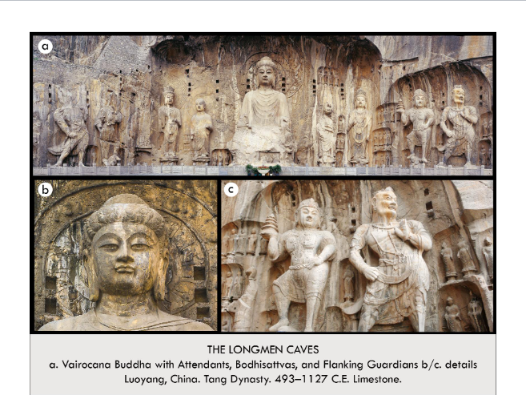

| **Form:** encompasses 2,345 shines and more then 100,000 statues, 2,800 inscriptions and numerous paintings. Modeled in rock, craved. Consists of main made rock caves.  **Function:**  A buddhist complex to meditate and comun. A pilgrimage sight, a place to be traveled to.  **Content:**  44 feet high surrounded by Bodhisattvas and guardians. And inscription states that in 672b the express Wu Zen paid for the project with her own funds. And the buddhas face may be her portrait. Guardians around the buddha.  **Context:**  3 grate systems of china, Buddhams, Taoism, and confushism. Started during the wai dynasty and completed in 676 under the tang  Shows the influence of india on china, and the widespread adoption of BUddhism at this time  **Compare:**  Bamiyan buddha  **195**  South, east & southeast asia |
| --- |

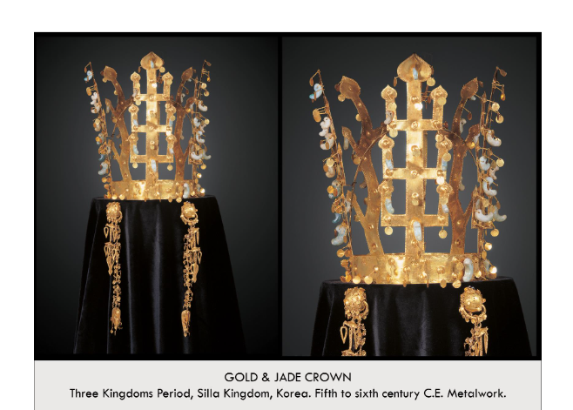

| **Form:**  Gold and jade. Hammered gold with jade ornaments,lightweight.  **Function:**  Ceremonial crown buried with the korean wisdom. Used for riyal and religious ceremonies in the nature- worshipping pre-buddhist Korean silla Kingdom  **Content:**  Geometric tree moti. An representation the the World tree an axis Mundi connecting heaven and earth. Ornaments hanging from the branches symbolize fertility and abundance .  **Context:**  Art of the silla kingdom all found in a tomb  **Compare:**  **196**  South, east & southeast asia |
| --- |

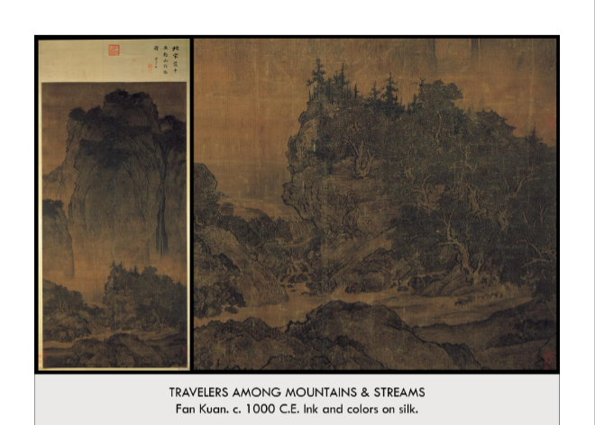

| **Form:** 7 feet tall . nature is depicted ina variety of brushstrokes, crated with ink. Texture of the rock surface. Linear strokes to depict the trees and rocks. Includes out lines. Contains multiple perspectives and are done/ created from memory.  **Function:**For beauty and decoration ,communication, to display of the spirit of the landscape. An elevation of nature. The communication of an experiment.  **Content:**  Painting the spirit of nature, crates ot indoors, does not create from a fixed viewpoint. Painted massive mountains in the distance with a shuberry seen from above. A waterfall on the right, balanced by a mountain crag on the left, leads to a stream and tree grove where two men drive donkeys along a forest path. The foreground is dominated by a great bolder seen from ground level. Signed by the artist in bottom corner.  **Context:** chinese literari paintes, painted landscapes. The song dynasty was the great flowering of landscape painting. The song ruling class made education, not heredity, the most important prerequisite. It was the renaissance of china.a time when china became more technologically advanced.  Images are not based on seeing but based on memories. Created by Fan Kuan: who was a taoist recluse, a respect for nature crated during the early song dynasty. Lives and meditated in nature, studied light, this is his only surviving work. Painters were scholars and poets, men of learning and amazing scholars.  **Compare:** Turner **( nature, the quality of nature)**  **201**  South, east & southeast asia |
| --- |

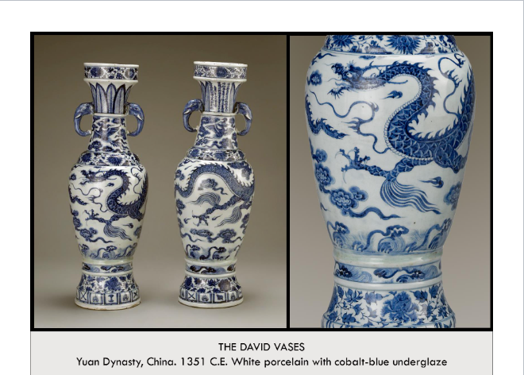

| **Form:**  White glazed pottery with cobalt blue, deep beautify white and blue glazed with chinese imagery. White porcelain vases with cobalt blue underglaze each 2’1” tall  **Function:**  as a prayer for protection and blessing of the who  **Content:**  They are two matching vases made as a gift with a matching incense bunnering which is missing for a taoist temple. There are text on the vessel which reads and offers this set to general Hu Jingyi. Imagery shows dragons, = male energy and phoenixes= female energy  **Context:**  Traditional chinese pottery. Very expensive at the time any created for the wealthy and influential. Created in the Yuan dynasty  **Compare:**  **204**  South, east & southeast asia |
| --- |

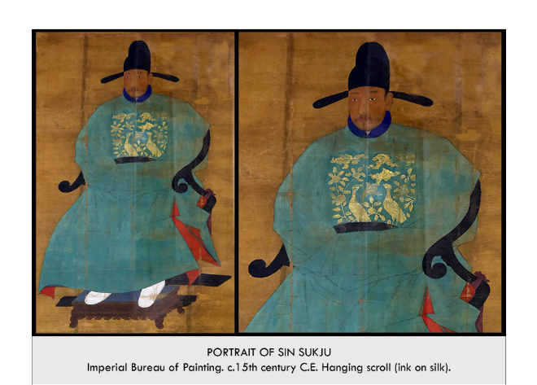

| **Form:**  Scroll painting on silk depicting a painted ruler  **Function:**  Ancestor portrait of the ruler, gift for a family  **Content:**  Flat are, asian, full of symbolism, shown as the perfect confusian ruler wearing an imperial silk robe. Cranes and birds= smart and ideal ruler. He is seated and has a gold rank badge depicting clouds, flowers and geese and bird= high rank  **Context:**  Example of asia ancestor portraiture. Created after the death of the person shows is dead and made for their family for their family shrine to honor them. He was the prime minister of china during his late life. Was made anonymously. Asian culture honors ancestors with full length portraits.  **Compare:** Portraiture Asian art  **205**  South, east & southeast asia |
| --- |

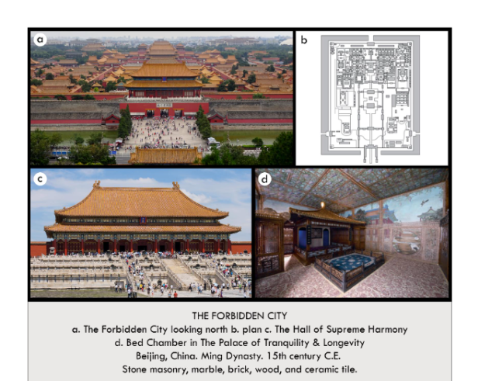

| **Form:** Built as three nested cities in a strict symmetry along a north/ south axis.  **Function:**  The imperial palace and political center of China during the ming and Quin dynasty. The home of 24 chinese emperors and their families.  **Content:**  The outer 15 mile perimeter encloses a 15 foot high walled imperial city with a perimeter of 6 miles culminating Dragons and lions decorating the complex. The roofs are 2 layered ( palace) many carved animals made out of brass and gold. Yellow and red colors= colors of power and the colors of china.  **Context:**  Created in the ming Dynasty of china. A wold heritage city. Originally built by ming dynasty architects over a 14 year period and 230,000 laborers in Beijing from 1406 to 1420. Chinese are the greatest wood architects. Today it is all unused.  **Compare:** palace of versace  **206**  South, east & southeast asia |
| --- |

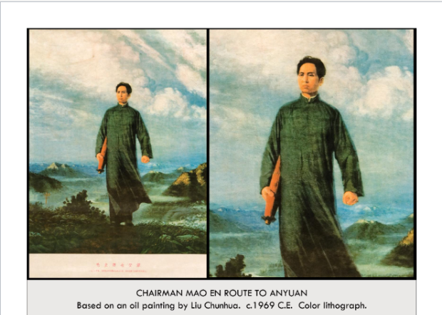

| **Form:**  Poster based off of an oil painting. Was not created in an asian style and has western influence  **Function:**  Political propaganda  **Content:**  Shows a young chairmen mao, he is depicted as he looked in the 1920s wearing traditional peasant garb in solidarity with the people -walking to the town of Anyuan to lead a miners strike, he has long hair to represent his journey umbrella symbolizes his willingness to walk.  **Context:**  You would never have your name on art in communist art. It was a heavily mass produced poster and was anonymously created over 900 million copied were created  **Compare:**  **212**  South, east & southeast asia |
| --- |

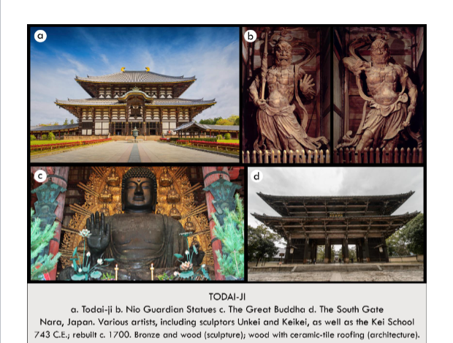

| **Form:** Wooden building, double roof leading up, pagoda style. Bronze buddha statue. Has the great buddha hall. Whole building held by large wooden carvings, no medal in the building,only held/made by wood.  **Function:**As a religious center, political function, to unite Japan ( all the different clans) with the same faith.  **Content:** Consists of a complex and statues and the great buddha hall. Gates entrance at the south gate, guardian figures at the gate that keep bad people out and protects the complex. Sculpture of Nio Guardian figures, demon fighters with large faces, weapons and fighting stances, carved out of wood. Surrounded by granary and beautiful gardens. Many buddhas surrounding the main stature od buddha.  **Context:** Largest buddhist temple in the world and largest wooden building in the word. Originally built in the mid-ninth century on th eastern edge of Japan. Razed during latter period. Smaller size then the original. Commissioned in Nara period by emperor Shomu. Worlds largest medal statue of the buddha. Great bronze casters and wood carversThere are many different buddhas.  **Compare:**  **197**  South, east & southeast asia |
| --- |

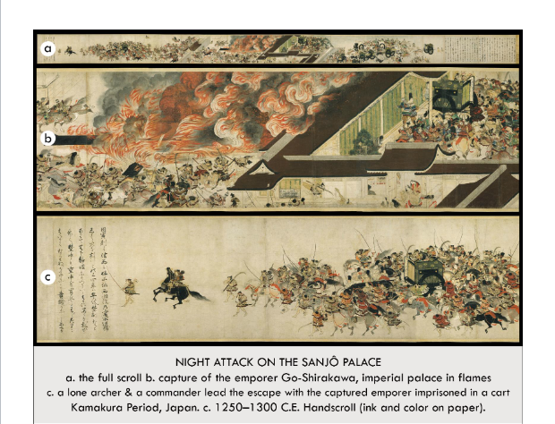

| **Form:** Calligraphy. Ink and color on paper. Different ink techniques and very detailed work  **Function:**Historical paining, to depict a historical even.  **Content:** The scroll depicts kyoto at a time of civil unrest japans military leader left the palace to pilgarame and the emperor is unprotected and rebels devise a plan to overtake the palace and kidnap the emperor. ( devised a cuoo) shows all types of people and figures, rebellious nobles, bowmen and others mover towards the imperial palace. Move along the scroll and come to the mote and gate, the rebellious captain ( fujoara) captures the emperors and burns down the palace and the palace is on fire, people fighting ( beautiful depiction of fire and smoke) shows much of people fighting and much violent conflict. People loyal to the emperor are killed and their heads are put on steaks. — the rebels lead the carriage with the emperor in it(kinddapining the emperor. And then the establishment of a military government at the end.  **Context:** Artists have workshops. This piece is not signed and we do not know who created. What workshop made this scroll. Currently heald in boston. Created during the Kamakura period  **Compare:** Bayeux tapestry, form of tragen  **203**  South, east & southeast asia |
| --- |

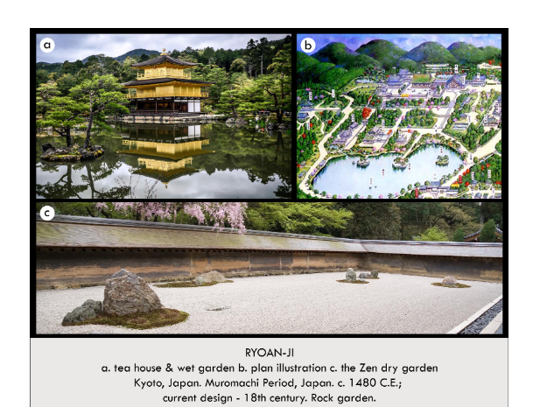

| **Form:** A rock garden. Zen Buddhism temple, A complex of 23 sub-temples  **Function:**Was created as a monastery sight in the 1480’s ( place for monks)  **Content:**  Grounds contained a temple. Wet garden with an 18th century tea house, living quarters for monks and a karesansui : dry landscape” garden. Bounded by an aged yellow low wall. Represents a floating island in the sea  **Context:**  Was created by the oldest Zen sect in Japan on land granted by the muromachi shogun Hosokawa Katsumoto  Ryoan-ji = Peaceful Dragon Temple= A great Zen center for the cultural activities of the elite during the 16th/17th centuries  The garden= Symbol of Zen Buddhism & Japanese culture, stones surrounded by white gravel - ironically little use of plants, This garden is one of the most famous examples of a rock garden, Inspired by aspects of Japanese & Chinese culture, Shinto (Japanese indigenous religion), Worship of deities in nature— Zen Buddhism  **Compare:**  **207**  South, east & southeast asia |
| --- |

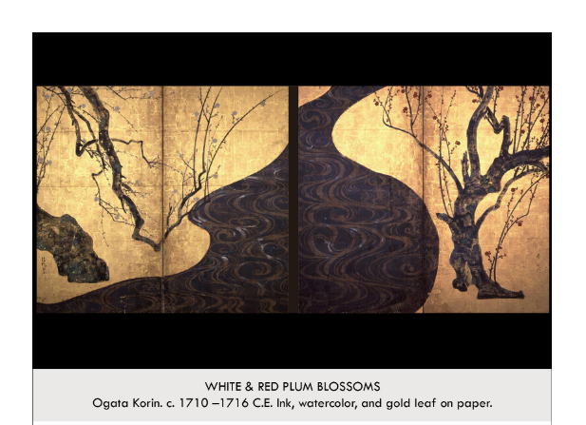

| **Form:**  A pair of 2 screen, watercolor on paper with gold leaf, and a wooden frame. ( Doors?)  **Function:**  Rome dividing and decorative, aristocratic, not a peasant pince ment for a tea house or some other noble building  **Content:**  Gold background of the Momoyama period. Flowing markes and much more patten oriented. Depicts different color plum blossesa in each side. It is mostly flat. A blending of perspectives. Different paining techniques paint applies to a surface that was already painted.  **Context:**  The rinpa school emerged on someone's name . Created during the edo period similar to the yamatoe style ( traditional style of JApan)  **Compare: -** mexico city screens  **210**  South, east & southeast asia |
| --- |

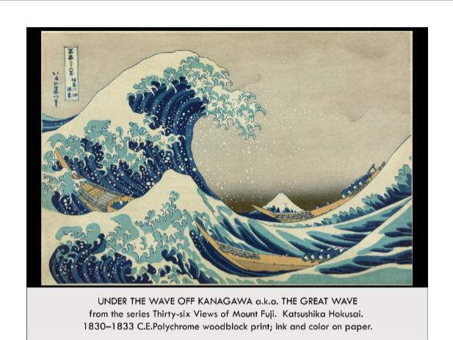

| **Form:**  Color wood black prints make by the general public  **Function:**  For decoration, to be collected and to be beautiful , to be enjoyed. ( Just to be beautiful)  **Content:**  This was a piece that was part of a series. Use of a new kind of blue called prussia blue( synthetic version of blue from russia) inside the action which shows western influence. But still very Japanese and very linean, no shadow ( linear use of triangles and curving lines) combination of japanese, western, and european. Fishing boats in the sea with mt. Fungi in the background.  **Context:**  Created by Hokusai = First great landscape wood block artists. He created pieces in series and made many different views of something the last of the 36 view of mount Fudie. Blue shows the influence from european art.  **Compare:**  **211**  South, east & southeast asia |
| --- |